Pertemuan 7
Nama | Alpratama Reqzama Khadka
No | 03
Kelas | TI-1C

Soal 1
Program
tarifCucian
Deklarasi

totalBerat: int
hargaPerKilo: int
total: int

Algoritma
INPUT totalBerat
If (totalBerat <= 3) THEN
hargaPerkilo = 7000
else if (totalBerat >= 6) THEN
hargaPerKilo = 6000
else
hargaPerKilo = 5000
total = totalBerat * hargaPerKilo
END IF
OUTPUT total

Soal 2
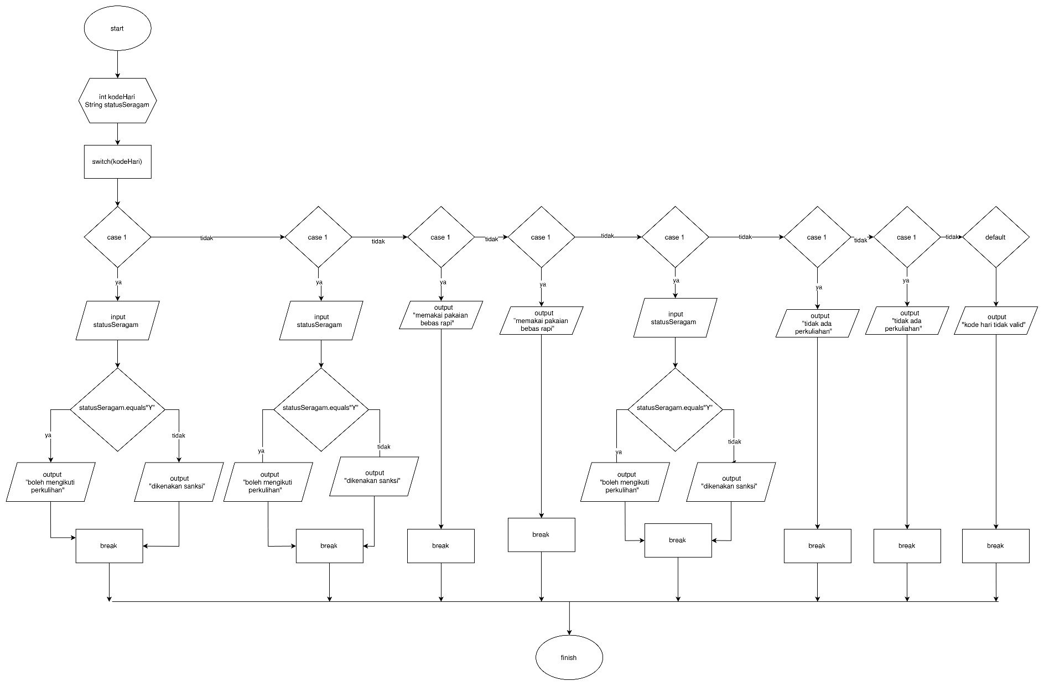
Soal 3
